|  |
| --- |
|  |
| **Shear Wave Velocity From CPT Tests in Christchurch** |
|  |
| **University of Canterbury**  **Department of Civil and Natural Resources Engineering** |
|  |
| **David Van Drimmelen** |
|  |
|  |
|  |
|  |

Executive Summary

The purpose of this document was to quantify the validity of a number of correlations for predicting 30 m shear wave velocity (Vs30) using cone penetration test (CPT) data. The correlations compared in this document were: Andrus, Hegazy, McGann, McGann2, and Robertson.

The first comparison was between CPT-Vs30 estimates and surface wave (SW) Vs30 estimates at 12 strong motion station (SMS) sites. The McGann2 CPT-Vs30 estimates were compared against the SW-Vs30 estimates for the loess soil sites, whereas the other four correlations were used on the general soil sites. The Andrus and McGann CPT-Vs30 estimates most closely followed the SW-Vs30 estimates, when compared to Hegazy and Robertson, which produced a far larger spread. McGann underestimated Vs30 on average, which was attributed to low-lying gravel/volcanic rock in the west; sites which were eastern were predicted better and vice versa. The Robertson and McGann2 estimations of CPT-Vs30 tended to be higher than the SW-Vs30 estimate.

The second comparison compared the methodology used by McGann et al. (2017) to the methodology used in this paper. The former was named the previous model and the latter was named the current model. McGann et al. (2017) approximated the entire 30 m CPT-Vs profile, whereas this document used a Vsz to Vs30 correlation where the CPT data did not reach 30 m. The McGann2 correlation was not used as none of the 7402 CPT data points used in this section were characterized as containing loess soil. The current McGann correlation was closest to the previous McGann correlation, followed by the Andrus correlation. The Hegazy and Robertson estimations provided the largest spread of data, which was exemplified by the large disparity between their mean and median predictions. A spatial variation was then considered. In the east, the current McGann model predicted higher on average when compared to the previous model – with the opposite observation in the west. This was again attributed to the shallowing of gravel/volcanic rock in the more western sites. Overall, sites which were predicted low by the previous McGann model were predicted even lower by the current McGann model and vice versa. Two explanations were proposed for this: McGann et al. (2017) overestimated or underestimated the Vs profile at some sites, and the Vsz to Vs30 correlation did not account for the soil behaviour. The data points were then separated into five different surficial geology categories: dune, estuarine, alluvium, swamp, and volcanic. No link was found between bias in estimate and the different categories. Termination depth was then considered; it was found that past a termination depth of 15 m, most of the high uncertainty points were eliminated, and that as the termination depth approached 30 m, the previous McGann model approached the current McGann model.

Table of Contents

[1. Strong Motion station comparisons 1](#_Toc13746766)

[1.1 Introduction 1](#_Toc13746767)

[1.2 Residual Correlation Error 1](#_Toc13746768)

[1.3 Different Correlations 3](#_Toc13746769)

[1.4 Site Profiles 3](#_Toc13746770)

[2. Christchurch correlation comparisons 5](#_Toc13746771)

[2.1 Introduction 5](#_Toc13746772)

[2.2 Spatial 6](#_Toc13746773)

[2.3 Surficial Geology 9](#_Toc13746774)

[2.4 CPT Depth 10](#_Toc13746775)

[3. References 12](#_Toc13746776)

[APPENDIX A. Vs CPT estimates for strong motion stations 14](#_Toc13746777)

[APPENDIX B. Explanation of Programming 16](#_Toc13746778)

[APPENDIX C. Method comparison using other correlations 24](#_Toc13746779)

[APPENDIX D. Surficial geology comparison using other correlations 26](#_Toc13746780)

[APPENDIX E. Termination depth for Christchurch CPT tests 29](#_Toc13746781)

# Strong Motion station comparisons

## Introduction

The purpose of this section is to quantify the validity of different correlations which estimate shear wave velocity (Vs) from cone penetration test (CPT) data. In order to quantify the validity of the CPT derived Vs profiles (CPT-Vs), they were compared to surface wave derived Vs profiles (SW-Vs) [1]. Christchurch strong motion sites (SMS) were used, and an emphasis was placed on the McGann correlation – which is explained later in this document. The locations of the strong motion sites are shown in Figure 1 [2]. Table 1 shows the SMS ID, station name, and surficial geology of each strong motion site [2].

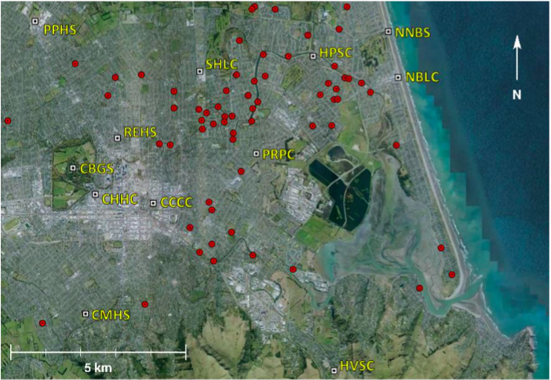

Figure 1. Location of the strong motion station sites

## Residual Correlation Error

For each method, Vs was correlated from CPT data at each incremental depth. A time-averaged shear wave velocity Vsz was then computed for the total depth before correlating this value, depending on depth, to a Vs30 value. Both the CPT data to Vs conversion and the Vsz to Vs30 conversion resulted in error. For the comparison of CPT-Vs30 errors, two different correlations were used. For the HVSC site the McGann2 correlation was used since this correlation is for Banks Peninsula loess soil [3], whereas for all other sites the general McGann CPT correlation was used [2]. Some sites had multiple CPT tests near the site location, and therefore for these sites there was more than one CPT-Vs30 estimation for the SW-Vs30 estimation. Figure 2 shows the comparison of CPT error for two different situations of error correlation. See the modelVerification.py section in Appendix B for an explanation about how these plots were produced. The dots represent the mean, and the error bars represent the distance of one standard deviation from the mean. Figure 2a shows the standard deviation sizes from the mean when no correlation between error was imposed on the estimation. Conversely, Figure 2b shows the size of one standard deviation from the mean when a perfect correlation between error was assumed. As the correlation was more perfect, the error of the CPT estimate increased. Two data points, CBGS and REHS3, were removed from all comparison figures (including Figure 2) since their CPT data started at a depth greater than 3 m. This is explained further in section 1.4.

Table 1. Summary of strong motion station sites

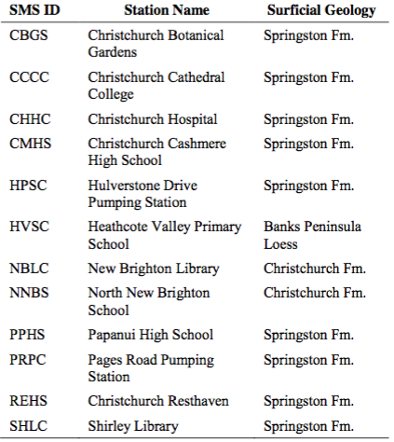

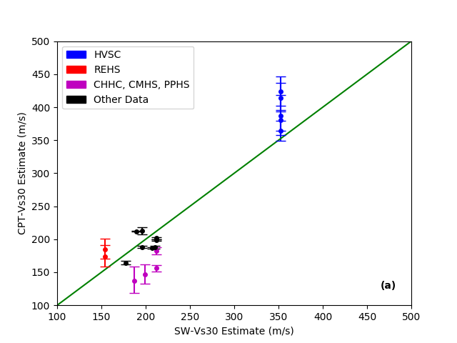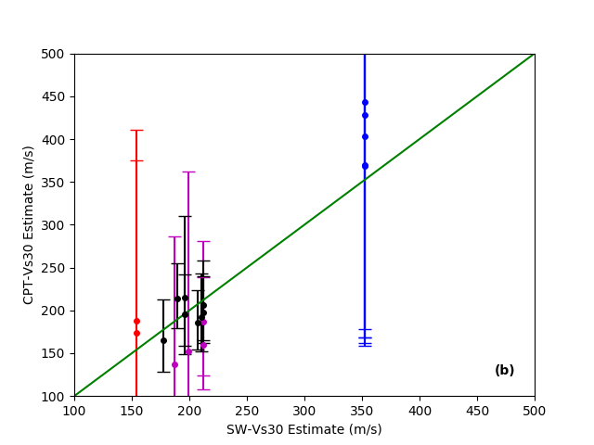

Figure 2. Comparison of standard deviation size for CPT Vs30 McGann/McGann2 estimates using different residual correlation: (a) zero and (b) perfect

## Different Correlations

Figure 3 shows CPT-Vs30 estimates using five different correlation types, and compares these to the SW-Vs30 estimate. See the siteComparison.py and siteComparisonPlot.py sections in Appendix B for an explanation about how these plots were produced. Zero-correlation for residuals was assumed for each correlation. The five different correlations were: Andrus, for Holocene-Age soils [4]; Hegazy, which is a global correlation [5]; McGann, which is a Christchurch specific correlation [2]; McGann2, which is a Banks Peninsula correlation for loess soils [3]; and Robertson, which is a unified approach [6]. The McGann2 correlation (magenta) was the only correlation which was appropriate for the HVSC site; this site is located in the mixed loess and volcanic colluvium deposits of the Banks Peninsula loess formation [2]. The four general CPT-Vs30 correlations – shown in blue, green, red, and light blue – can be compared against the SW-Vs30 estimations for the general soil sites.

The Andrus and McGann CPT-Vs30 estimates most closely followed the SW-Vs30 estimates. McGann, however, tended to under-estimate Vs30 compared to the SW-Vs30 estimate on average for this data set. This was due to CPT test failure at the gravel or volcanic rock interface, and will be explained further in section 1.4.

The Hegazy and Robertson estimations gave a large spread, which was likely due to the sensitivity with respect to variations in soil properties that these methods account for. The Robertson estimations tended to overestimate Vs30. The McGann2 estimates tended to overestimate the small data set which is shown in Figure 3.

## Site Profiles

For consistency, all of the graphs shown in this section were produced using the McGann correlation, except the HVSC profiles shown in Appendix A for which the McGann2 correlation was used. See the main.py section in Appendix B for an explanation about how these plots were produced.

REHS3 and CBGS – shown in Figure 4c and Figure 4d, respectively – were removed from Figure 2 and Figure 3, as the CPT data started at a depth greater than 3 m. The REHS3 data started at approximately 14 m and the CBGS data started at 10 m. The method used in this document worked by assuming that any missing data before the start of the CPT data was constant, and therefore using CPT data which started deeper than approximately 3 m would have produced unreliable CPT-Vs30 estimates. CPT data which started at 3 m or shallower, provided the total depth exceeded 5 m, was kept as an estimate since the error they accrued from the Vsz to Vs30 correlation was a fair reflection of their predictive ability (for example, see Figure 4a and Figure 4b).

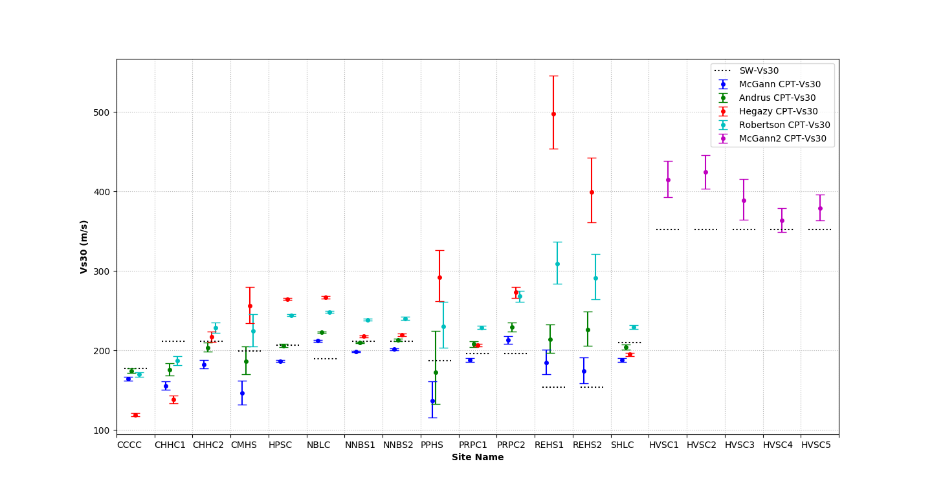

Figure 3. Estimates of CPT-Vs30 using zero-correlation residual assumption for five different correlation types compared against SW-Vs30 estimates

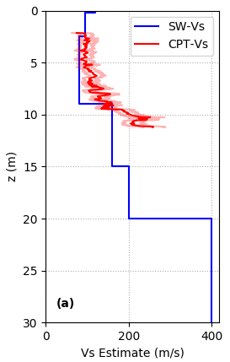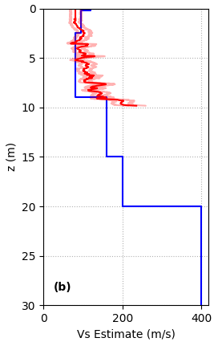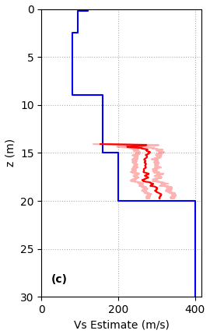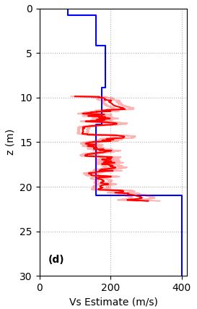

Figure 4. Vs profiles at (a) REHS1, (b) REHS2, (c) REHS3, and (d) CBGS, where the lighter red data is one standard deviation away from the CPT-Vs estimate

The CHHC, CMHS, and PPHS sites were underestimated by the McGann correlation as shown in Figure 3. These were also the most western SMS locations when CBGS was excluded. The profiles for CMHS, CHHC1, CHHC2, and PPHS are shown in Figure 5. All four sites exhibited spikes in CPT-Vs at lower depths, which corresponded to the cone reaching stiffer soils. The CPT test failed at this point – leading to a lower estimate of CPT-Vs30 due to a lack of CPT-Vs at greater depths. This stiffer soil was attributed to gravel or volcanic rock, which sits at a shallower depth near the city centre (~15 m) when compared to the shoreline (up to 40 m near the Avon-Heathcote Estuary) [1].

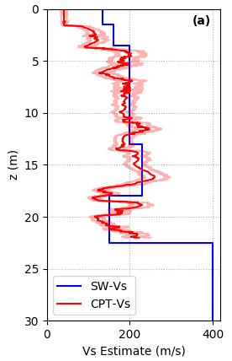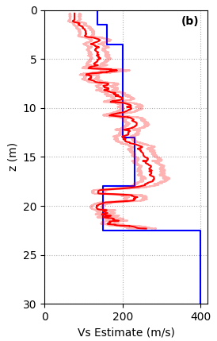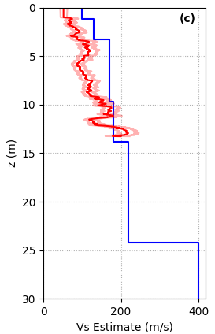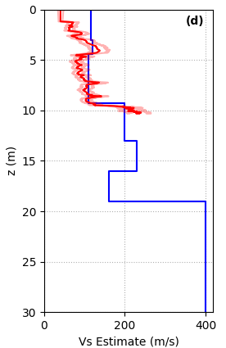

Figure 5. Western Vs profiles: (a) CHHC1, (b) CHHC2, (c) CMHS, and (d) PPHS, where the lighter red data is one standard deviation away from the CPT-Vs estimate

The distributions in Figure 5 were then compared to the more eastern estimates shown in Figure 6. Figure 6a shows the Vs distribution from NBLC, and Figure 6b and Figure 6c show the Vs distributions from NNBS1 and NNBS2, respectively. All of these estimates were located in New Brighton, where the depth to the gravel/volcanic rock is far deeper than it is near the city centre. As a result, the CPT data extended close to 30 m in depth, which lead to significantly less bias in the CPT-Vs30 estimate, as it more closely followed the SW-Vs30 estimate. The other five CPT-Vs correlation profiles for the McGann correlation and five McGann2 correlation profiles for the HVSC site can be found in Appendix A: Figure A1 – Figure A5.

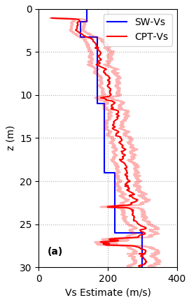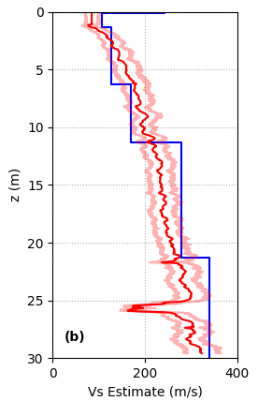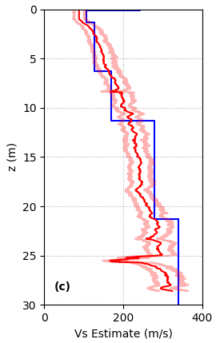

Figure 6. Eastern Vs profiles: (a) NBLC, (b) NNBS1, and (c) NNBS2, where the lighter red data is one standard deviation away from the CPT-Vs estimate

# Christchurch correlation comparisons

## Introduction

The purpose of this section was to compare the output of the methodology used by McGann et al. (2017) [1] with the methodology used in this document. McGann et al. (2017) used an approximation of the surficial geological profile at the site to assume each entire 30 m Vs profile where the CPT test failed due to gravel or volcanic rock. Comparatively, this document used a Vsz to Vs30 correlation, so that no further Vs profile was explicitly assumed other than the one provided from the CPT data correlation. These two methodologies will be henceforth referred to as the previous method and current method, respectively. The paper used the same McGann CPT correlation as this document. All of the correlations used in this document – McGann, Andrus, Hegazy, Robertson, and McGann2 – use the current method. 7402 CPT data points were used in this comparison in the greater Christchurch area. Note that in this section all estimates refer to CPT-Vs or CPT-Vs30 estimates; these estimates will simply be referred to as Vs and Vs30. Zero-correlation for residuals was assumed for all plots in section 2.

## Spatial

Figure 7 shows the estimations of Vs30 for both the previous and current method, whereas Figure 8 shows the ratio of the previous estimate over the current estimate, as well as the depth to the gravel or volcanic rock for the physical interpretation of the disparities between the two models. See the christchurchCPTmapping.py and ratioForMapping.py sections in Appendix B for an explanation on how the data used for mapping was computed and formatted. Once the estimations were in the correct format, the same GMT mapping script used by McGann et al. (2017) was used to create the maps.

In Figure 8a, the lower bound – shown in light blue – is 0.8, whereas the upper bound – shown in magenta – is 1.2. Figure 8a shows the previous estimate over the current estimate, so ratios larger than 1 show evidence of a relative under-prediction of the current estimate and vice versa. Closer to the shoreline, where the gravel layer is deeper, the current method overestimated Vs30 compared to the previous model. Farther away from the shoreline, the current method estimated Vs30 lower than the previous estimate. The farther west the estimate, the shallower the gravel or volcanic rock sits, and the greater the current model under-predicted relative to the older model. This was seen in Figure 5; the lack of CPT information past where the test failed at the gravel or volcanic rock lead to a lower estimation of Vs30. Further evidence of this is shown in Figure E1, which shows the termination depth of the CPT tests. The same pattern is seen in Figure E1 to Figure 8b, except that the termination depth in the east tended to be shallower than the gravel/volcanic rock interface. Due to this, ratios in Figure 8a show a similar distribution to that which is shown in Figure 7a and Figure 7b, meaning that the values which were predicted to have low Vs30 values using the previous McGann model were predicted to have even lower values using the current model and vice versa. This was further backed up by Figure 9, which shows that higher values in the previous McGann estimate were predicted higher in the current McGann estimate and vice versa. Two explanations were: the extrapolations of the Vs profile by McGann et al. (2017) overestimated or underestimated the soil behaviour at the site, or the Vsz to Vs30 correlation did not sufficiently account for the soil behaviour (in the east this was an overestimate and in the west this would an underestimate). It was likely some combination of these two explanations. This east to west spatial variation was not without exception, especially with the western Vs30 predictions. The more western predictions contained a larger variability in their estimations; this was likely associated with the relatively low termination depth (see Figure E1), meaning that a large portion of the profile was implicitly estimated using the Vsz to Vs30 correlation. This explains the scatter of data points less than 1 amongst the majority of points which were greater than 1 in the west, as shown in Figure 8a.

Figure C1 – Figure C3 show the Andrus, Hegazy, and Robertson estimates, respectively. The McGann2 correlation was not used since none of the data points have the surficial geology which this correlation accounts for: loess soil. All of the estimations shown in Appendix C predicted a higher Vs30 on average than the previous McGann estimate. The Hegazy and Robertson estimates, as seen previously in Figure 3, were highly variable. The maps produced have a range of 0.8 to 1.2 and 150 m/s to 230 m/s, and therefore since the average estimates were an overestimate, the large spread of these two estimates is not shown in Figure C1 and Figure C2. Andrus was the estimate which was closest on average to the previous McGann estimates of these three, but still had a slightly higher estimate. Furthermore, a similar spatial variation in ratio was seen in the Andrus estimate when compared to the McGann estimate in this document. As the estimates moved farther west, the ratio value increased, meaning that the Andrus estimate increased relative to the previous McGann estimate. The same explanation with respect to the shallowing of gravel/volcanic rock farther west of the shoreline can be made as previously stated (see Figure 8b).

Figures/Vs%20plots%20/old_McGann.pdfFigures/Vs%20plots%20/McGann.pdf

(a) Previous estimate (b) Current estimate

Figure 7. Estimates of Vs30 from McGann, Bradley et al. (2017) and this document in m/s

../../ratioMcGann.pdfFigures/Gravel:Failure%20point%20plots/plot_gravel.pdf

(a) Ratio plot (b) Depth to rock/gravel in m

Figure 8. Ratio of the previous McGann estimate over the current McGann estimate, with a depth to gravel or volcanic rock estimate for comparison

The median and mean ratios were also observed for each estimate, and are shown in Table 2. The first thing observed from Table 2 was the extraordinarily high mean value in the Hegazy estimate. The Hegazy estimates ranged from almost 0 m/s to over 1000 m/s. Since the ratio was determined by the previous McGann estimate over the Hegazy estimate, the mean was skewed towards the extremely high ratio estimates (sometimes on the order of ~10,000). A similar observation was made with the Robertson estimates, with the mean ratio falling significantly higher than the median ratio. Recognising this bias in the mean, the median ratio was a more useful tool for describing the predictability of Hegazy and Robertson compared to the previous McGann estimate; both predictions overestimated Vs30. Although the Andrus correlation most closely followed the previous McGann correlation with the exception of the current McGann correlation, both the median and the mean showed that the Andrus estimates were still generally higher on average. Table 2 also shows that the difference between the typical previous McGann estimate and the typical current McGann estimate was insignificant, with a median ratio of 0.98 and a mean ratio of 1.03. There was therefore not a typical overall difference between these two models, but an important spatial variation between these two predictions was still observed. That is, with regard to the current McGann estimate, the overestimates in the east appeared to cancel the western underestimates, when compared to the previous McGann estimates. Additionally, mean and median ratios depended on the density of estimates in given regions; if all of the estimates were in the east, ratio values would have been on average lower than observed in this document.

Table 2. Mean and median ratios for the McGann, Andrus, Robertson, and Hegazy estimates

|  |  |  |
| --- | --- | --- |
| Estimate | Median | Mean |
| McGann | 0.98 | 1.03 |
| Andrus | 0.83 | 0.86 |
| Hegazy | 0.68 | 626 |
| Robertson | 0.71 | 1.11 |

## Surficial Geology

In order to understand how surficial geology effected the different correlations estimates, the data was separated into seven different categories, namely: dune, estuarine, anthropic, alluvium, swamp, loess, and volcanic. However, two of these categories, anthropic and loess, contained no data points. Five plots were made for each correlation for the remaining categories. The McGann plots are shown in Figure 9. The Andrus, Hegazy, and Robertson correlation plots are shown in Figure D1 – Figure D3, respectively. The same explanation for why the McGann2 plots were not produced can be made as previously stated. See the christchurchCPTmapping.py, surficialGeologyExtractor.py, and the plotData2.py sections in Appendix B for more information about how these plots were produced.

Similar trends were found between the four correlations as previously observed when considering all surficial geology: the McGann correlation had the closest representation, the Andrus correlation was the second closest, and the Robertson and Hegazy correlations had the largest spread of data. All of the geology categories had a similar distribution of estimates, as seen in Figure 9 and Figure D1 – Figure D3. This observation was independent of the used correlation (for those presented in this document).

## CPT Depth

In order to explore the impact of the CPT termination depth on both error and prediction disparity between the previous and current McGann model, only Vs30 predictions which were within certain depth bounds were plotted. Six depth bounds were considered, namely: 5-10 m, 10-15 m, 15-20 m, 20-25 m, 25-30 m, and over 30 m. See the termDepthLimiter.py and the plotAllData.py sections in Appendix B for more information about how these plots were produced.

The larger the CPT termination depth, the lesser the uncertainty on each data point was, and the closer the previous and current estimates were to each other. As the data points approached 30 m in depth, the closer the two models were to each other. Comparison of Figure 10b and Figure 10c shows that past a CPT termination depth of 15 m, most of the high uncertainty data points were removed. It was also observed that most of the points which were estimated higher by the current McGann model had a termination depth of between 5-15 m. Therefore, past a termination depth of 15 m, the main source of disparity between the two models was explained by failure at the underlying gravel/volcanic rock – leading to a relative underestimate from the current McGann model.

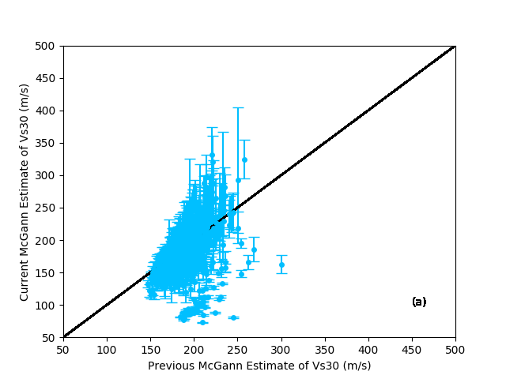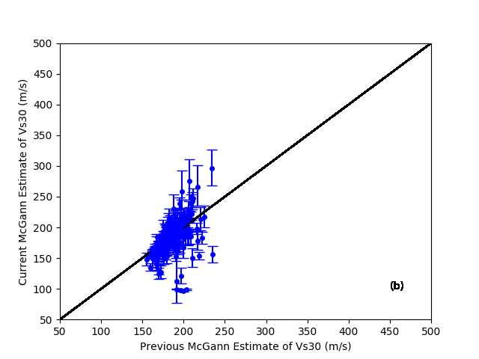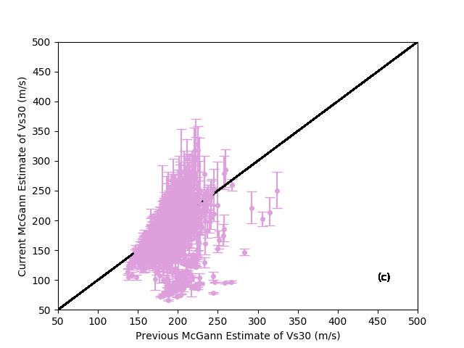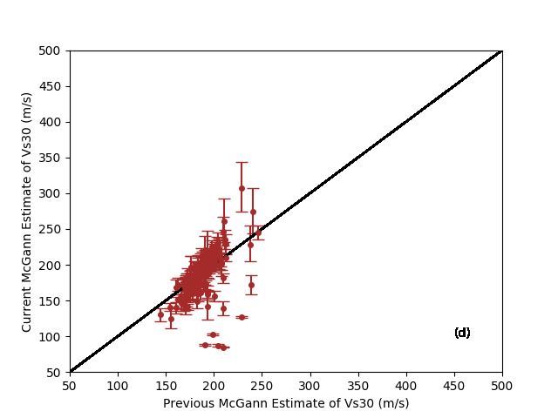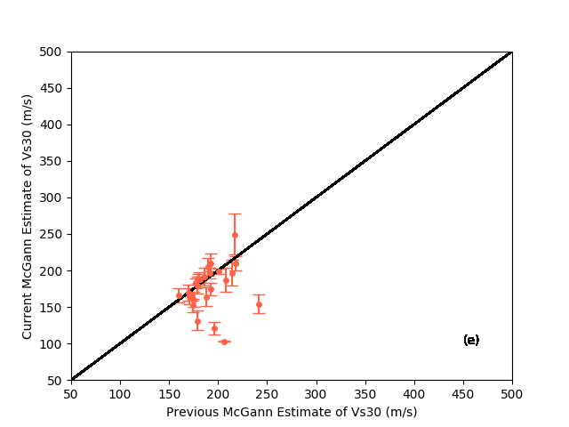

Figure 9. Vs30 estimates for McGann split into five different surficial geology types: (a) dune, (b) estuarine, (c) alluvium, (d) swamp, and (e) volcanic

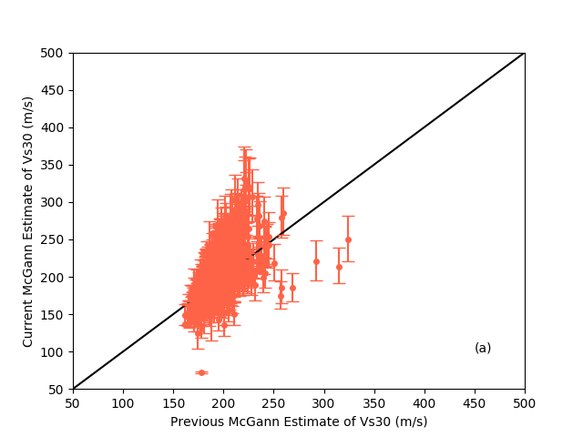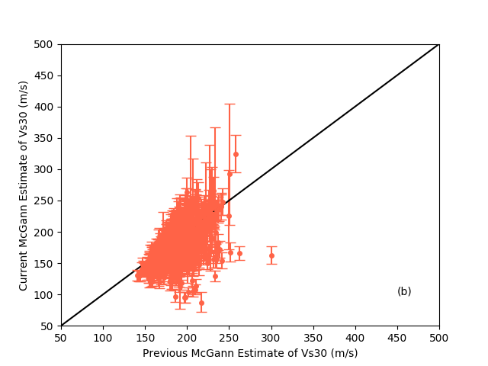

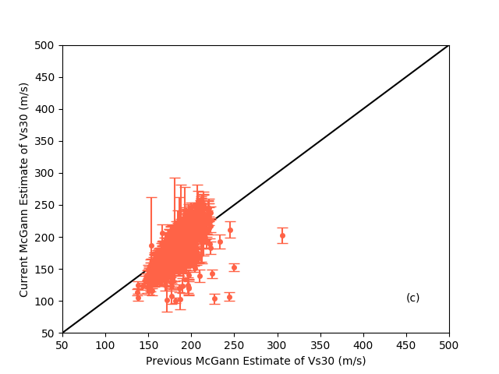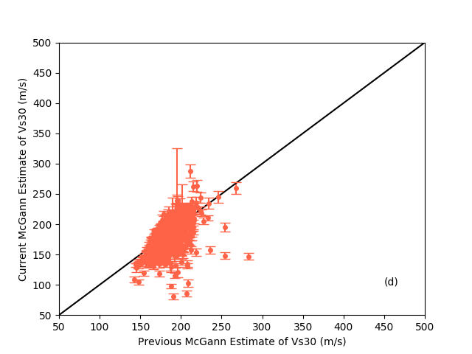

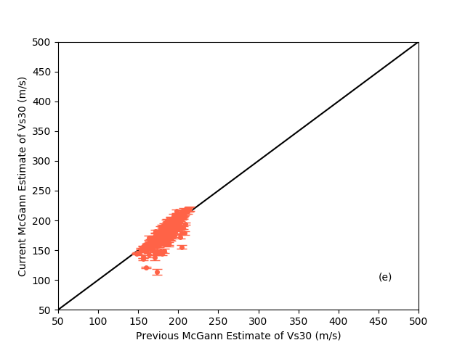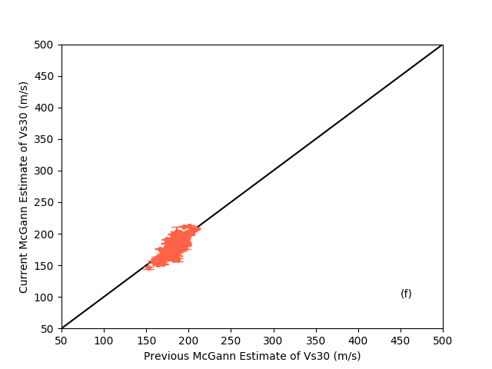

Figure 10. Vs30 estimates for McGann split into six different CPT termination bounds: (a) 5-10 m, (b) 10-15 m, (c) 15-20 m, (d) 20-25 m, (e) 25-30 m, and (f) over 30 m

# References

1. McGann, C.R., B.A. Bradley, and M. Cubrinovski, *Development of a regional Vs30 model and typical Vs profiles for Christchurch, New Zealand from CPT data and region-specific CPT-Vs correlation.* Soil Dynamics and Earthquake Engineering, 2017. **95**: p. 48-60.

2. McGann, C.R., et al., *Development of an empirical correlation for predicting shear wave velocity of Christchurch soils from cone penetration test data.* Soil Dynamics and Earthquake Engineering, 2015. **75**: p. 66-75.

3. McGann, C.R., B.A. Bradley, and S. Jeong, *Empirical correlation for estimating shear-wave velocity from cone penetration test data for banks Peninsula loess soils in Canterbury, New Zealand.* Journal of Geotechnical and Geoenvironmental Engineering, 2018. **144**(9): p. 04018054.

4. Andrus, R.D., et al. *Predicting shear-wave velocity from cone penetration resistance*. in *Proceedings of the 4th International Conference on Earthquake Geotechnical Engineering, Thessaloniki, Greece*. 2007.

5. Hegazy, Y.A. and P.W. Mayne, *A global statistical correlation between shear wave velocity and cone penetration data.* GEOTECHNICAL SPECIAL PUBLICATION, 2006. **149**: p. 243.

6. Robertson, P., *Interpretation of cone penetration tests—a unified approach.* Canadian geotechnical journal, 2009. **46**(11): p. 1337-1355.

1. Vs CPT estimates for strong motion stations

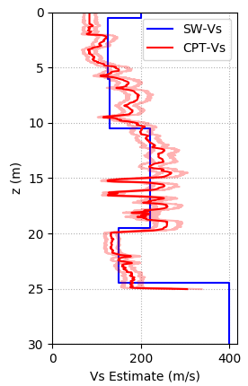

Figure A1. Vs profile for CCCC using the McGann correlation, where the lighter red data is one standard deviation away from the CPT-Vs estimate

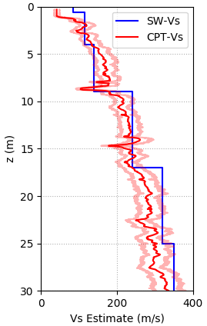

Figure A2. Vs profile for HPSC using the McGann correlation, where the lighter red data is one standard deviation away from the CPT-Vs estimate

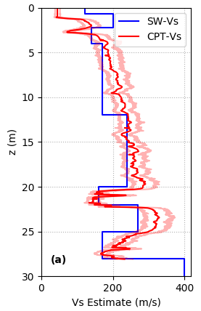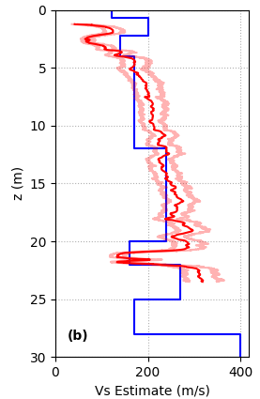

Figure A3. Vs profiles for (a) PRPC1 and (b) PRPC2 using the McGann correlation, where the lighter red data is one standard deviation away from the CPT-Vs estimate

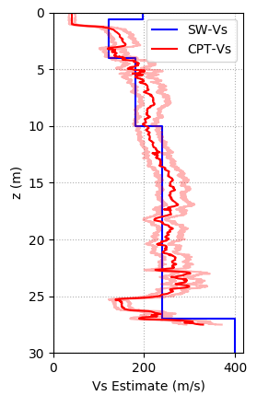

Figure A4. Vs profile for SHLC using the McGann correlation, where the lighter red data is one standard deviation away from the CPT-Vs estimate

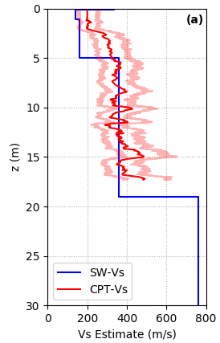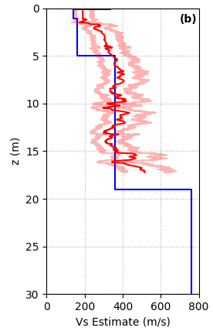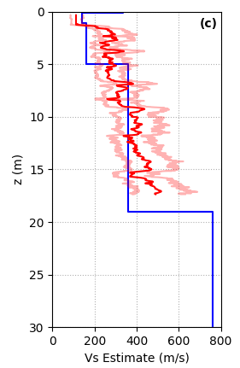

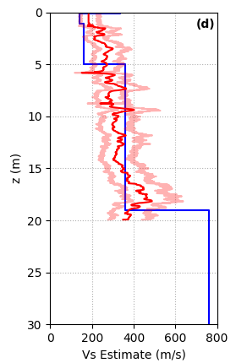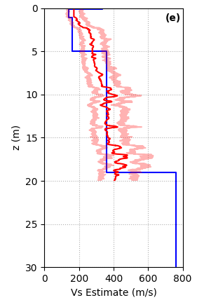

Figure A5. Vs profiles for (a) HVSC1, (b) HVSC2, (c) HVSC3, (d) HVSC4, and (e) HVSC5 using the McGann2 correlation, where the lighter red data is one standard deviation away from the CPT-Vs estimate

1. Explanation of Programming

All functions used for this report are heavily commented and thus this section is to be used as supplemental explanation to the code. It should be noted that all files and sub-functions used are assumed to be in the same folder as the function which is being used.

**modelVerification.py**

Figure B1 shows the flow path used to produce one-to-one plots of CPT estimates against strong motion station estimates. The blue arrows show the overall flow path; modelVerification calls to computePlotData, printData, and plotData. These subsequent functions are relatively simple, and thus the commenting of the code should be sufficient to understand them. The smaller orange arrows and the subsequent different colours show further embedded functions which are called to. The function works by calling to a file which contains the filenames of all the CPT and SMS files. These names are then extracted in order to call to the subsequent files. These files are then iterated through, extracting out the CPT and Vs data. This data is then used to produce Vs30 estimates and, in the case of the CPT data, Vs30 standard deviations from the mean. This data is then printed to the screen and plotted. A for loop is used to distinguish the colour of the points, using the station names recovered from the file which contains the CPT and SMS filenames. For more information on the production of Vs30 estimates, see Claire Dong’s *Explanations* document.

It should be noted that for the production of Figure 2 computePlotData was replaced with computePlotData1. The only difference being that this function enabled 14 out of the 19 Vs30 estimates to be computed using the McGann correlation and the remainder using the McGann2 correlation (i.e., the HVSC site data). If computePlotData is used only one correlation can be used for all of the data points.

Programming/modelVerificationFlowPath.pdf

Figure B1. Flow path for producing one-to-one comparison plots of strong motion station estimates of Vs30 against CPT estimates of Vs30

Inputs:

* A text file containing CPT filenames and a text file containing SW filenames (which then calls to the actual text files).
* The correlation to be used (e.g., McGann). This is not needed for computePlotData1 (assumes McGann and McGann2 are used).
* The error correlation type: no correlation or perfect correlation.

Outputs:

* Prints to the screen the precise estimates of CPT and SMS at each site.
* Plots the estimates one-to-one for each site with error on the CPT estimates. Colours some estimates to distinguish site locations for analysis.

**siteComparison.py**

This function works by reading the same text files as explained in modelVerification.py, which contain the CPT and SW filenames. An ‘SW’ file is then made by extracting the SW-Vs data for each estimate and converting this into a Vs30 estimate (by calling to getVsData and computeVs30smt). The ‘SW’ file is a single column of 19 rows (each row contains a SW-Vs30 estimate for a site). An ‘other’ file is made by extracting the CPT data for each site and converting this into four CPT-Vs30 estimates with uncertainties (by calling to getCPTdata and computeVs30) – one estimate for each of the McGann, Andrus, Hegazy, and Robertson estimates. The ‘other’ file contains 12 columns (each estimate has a mean, a lower standard deviation, and an upper standard deviation) and 14 rows. Finally, the ‘HVSC’ file is made by extracting CPT data for the HVSC site and using the McGann2 correlation to compute a CPT-Vs30 estimate (by calling to getCPTdata and computeVs30). The ‘HVSC’ file contains 3 columns and 5 rows.

Inputs:

* A text file containing CPT filenames and a text file containing SW filenames (which then calls to the actual text files).
* The error correlation type: no correlation or perfect correlation.

Outputs:

* A text file containing the SW-Vs30 estimates (1 column and 19 rows).
* A text file containing the ‘other’ CPT-Vs30 estimates (12 columns and 14 rows).
* A text file containing the ‘HVSC’ CPT-Vs30 estimates (3 columns and 5 rows).

**siteComparisonPlot.py**

This function works first by taking the CPT filenames and removing the suffix ‘.txt’ so that the filenames can be used as the text below the x-ticks. The SW estimates are then extracted from the ‘SW’ file and plotted at a hard-coded step size using a for-loop. A list for the tick-marks is also created in this for-loop. The McGann, Andrus, Hegazy, and Robertson estimates are then plotted in a for loop from the ‘other’ text file. The McGann2 estimates are then produced for the final HVSC site from the ‘HVSC’ file in a final for-loop. An if statement is used in both of the CPT for-loops to produce only one label for each estimate.

Inputs:

* A text file containing the SW-Vs30 estimates (1 column and 19 rows).
* A text file containing the ‘other’ CPT-Vs30 estimates (12 columns and 14 rows).
* A text file containing the ‘HVSC’ CPT-Vs30 estimates (3 columns and 5 rows).
* A text file containing CPT filenames.

Outputs:

* A plot which compares the SW-Vs30 estimates against the CPT-Vs30 estimates (see Figure 3).

**main.py**

All of the functions shown in Figure B2 are explained fully in Claire Dong’s *Explanations* document. Some changes have been made since this document was written: any delimiter term has been removed from all load text expressions (for more generality), computeVs now returns standard deviation Vs30 terms from the mean – and main accounts for this, and the function now plots the Vs standard deviation on the Vs profile. The computeVs function has also been changed so that the expected value is computed by assuming a lognormal distribution for both the 0 and 1 correlation cases; however, it should be noted that the expected value was not shown in the figures in this document. The u2 parameter should also be adjusted depending on the units it is presented as in the text file. For example, for the SMS data it does not need to be converted, but for the Christchurch-wide data it must be divided by 1000 to maintain consistency across variables. It should also be noted that the graphs are actually plotted within computeVs, which calls to the SMS file, and uses the CPT data and parameters drawn from both getCPTdata and getCPTparam.

Programming/mainFlowPath.pdf

Figure B2. Flow path for producing Vs profiles for the strong motion sites

Inputs:

* A CPT text file and the SMS text file (the latter is inputted into computeVs).
* The correlation to be used (i.e., McGann).
* The error correlation type: no correlation or perfect correlation.

Outputs:

* A Vs profile plot.
* Can be changed to output specific values to screen.

**christchurchCPTmapping.py**

Figure B3 shows the flow path used to produce Vs30 estimates for a number of CPT sites, before printing to a file which can then be used to plot these estimates on a map. The function works by reading a meta-file which contains CPT IDs, as well as longitudes and latitudes, which correspond to sites. The IDs, longitudes, and latitudes are extracted into lists in python. The IDs are then used to read each CPT data file in a for loop, before calling to computeVs30 at each iteration. During each iteration the longitude, latitude, and Vs30 estimate are written as a line in a text file. Therefore, once the for loop has been run, the text file will contain n rows and 3 columns, where n is the number of lines in the initial meta-file which contained the site IDs. However, for the production of the error plots, columns which contained uncertainty were appended to the output file, producing n rows and 6 columns.

Programming/christchurchCPTmappingFlowPath.pdf

Figure B3. Flow path for producing Vs30 estimates and printing to a file for mapping

Inputs:

* A text file containing IDs, longitude, and latitude for a number of CPT sites (which is then used to call to the actual CPT files).
* The correlation to be used (e.g., McGann).
* The error correlation type: no correlation or perfect correlation (although this does not affect the output, if uncertainties are not included in the text file output).

Outputs:

* Returns a text file containing the longitude, latitude, and Vs30 estimates at each location (other columns were added in order to produce the error plots: log standard deviation of Vs30, lower standard deviation from the mean, and the upper standard deviation from the mean).

**ratioForMapping.py**

The function first reads the two input files which have the same format produced by christchurchCPTmapping.py. The function then takes the longitude, latitude, and the two estimates each as lists. The function then turns the estimate lists into arrays so that they can be divided by each other. The longitude, latitude, and the ratio of the two estimates is then read in a for loop, with each iteration writing a line in a file with the same format as the input files.

Inputs:

* Two filenames which both contain the formatting which is produced by christchurchCPTmapping.py.

Outputs:

* Produces the same file structure as the input (i.e., lines of longitude, latitude, and a value to be plotted), except the value to be plotted in this case is a ratio of the two Vs30 estimations.

**surficialGeologyExtractor.py**

This function reads a csv input file which contains both the ID number and nuanced geology description for each site. These are both converted into arrays. The geology is then passed through a for loop which simplifies the geological description into seven different categories: dune, estuarine, anthropic, alluvium, swamp, loess, and volcanic. If none of these categories are found in the more nuanced description the new list will have the string ‘none’ for that given element. This list is then shortened based on a text file which contains a subset of IDs that are needed.

Inputs:

* CSV file which contains the ID and nuanced geology of each site.

Outputs:

* Simplified geology for the subset of CPTs which are contained in the secondary file.

**plotData2.py**

This function works by extracting the base prediction for the values to be plotted on the x-axis, the new Vs30 prediction, the lower prediction, and the upper prediction for the values to be plotted on the y-axis. The latter predictions are from text files produced by christchurchCPTmapping.py. The lower and upper error is then computed and shaped in an array for plotting. The geology is then extracted for each site as outputted by the surficialGeologyExtractor.py function. A for loop is then used to produce five different plots for each of the surficial geology types (since for this case only five of the seven geology types were needed).

Inputs:

* A base text file which contains the previous estimates.
* A text file which contains a new estimate with uncertainties (6 total columns).
* A text file containing simplified surficial geology.

Outputs:

* Five plots; that is, one for each of the five geological categories (since only five of the seven surficial geological categories were necessary for this study).

**TermDepthLimiter.py**

This function works first by extracting the columns from a file which is of the same form as the output from christchurchCPTmapping.py (the type which contains uncertainty) and the termination depth from the termination depth file. The function then iterates through a for loop which limits the data points depending on their termination depth. A new file is then written with the limited number of data points. The minimum termination depth and maximum termination depth are variables that can be changed in the function.

Inputs:

* A file which contains the full amount of data points with uncertainty, and in the same format as created by christchurchCPTmapping.py.
* A file which contains the termination depth of each data point.

Outputs:

* A file which contains a limited number of data points depending on the termination depth, and in the same format as created by christchurchCPTmapping.py.

**plotAllData.py**

Works in the same way as plotData2.py, except it does not separate the data points into different surficial geologies and produces only one plot. This makes the function very simple.

Inputs:

* A base text file which contains the previous estimates.
* A text file which contains a new estimate with uncertainties (6 total columns).

Outputs:

* One plot with uncertainties of each Vs30 estimate.

1. Method comparison using other correlations

../../ratioAndrus.pdfFigures/Vs%20plots%20/Andrus.pdf

(a) Vs30 in m/s (b) Ratio

Figure C1. Andrus estimate and ratio of previous McGann estimate over the Andrus estimate

../../ratioHegazy.pdfFigures/Vs%20plots%20/Hegazy.pdf

(a) Vs30 in m/s (b) Ratio

Figure C2. Hegazy estimate and ratio of previous McGann estimate over the Hegazy estimate

../../ratioRobertson.pdfFigures/Vs%20plots%20/Robertson.pdf

(a) Vs30 in m/s (b) Ratio

Figure C3. Robertson estimate and ratio of previous McGann estimate over the Robertson estimate

1. Surficial geology comparison using other correlations

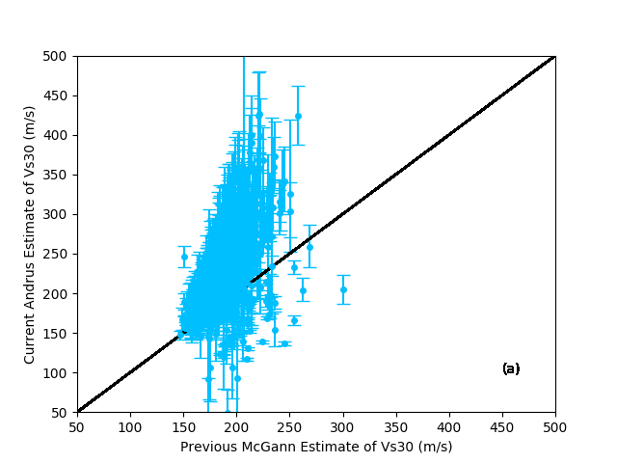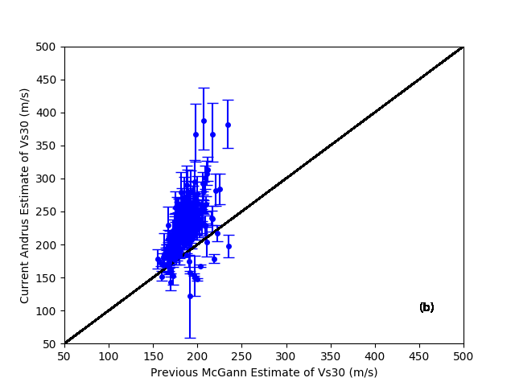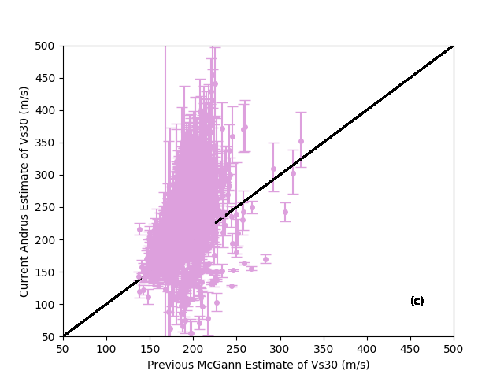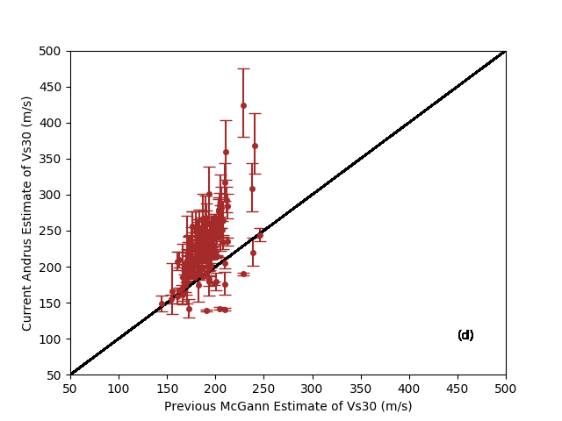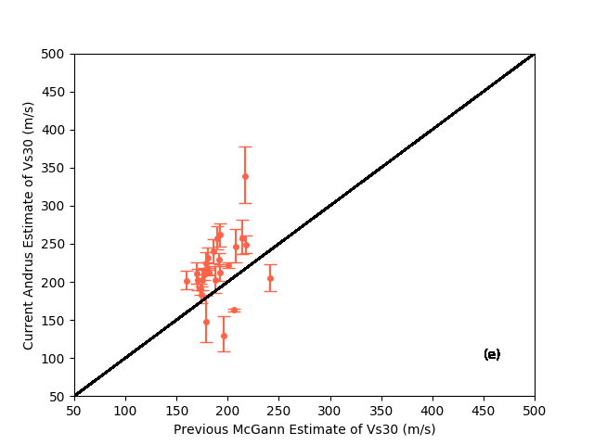

Figure C1. Andrus correlation estimates divided into five surficial geology categories: (a) dune, (b) estuarine, (c) alluvium, (d) swamp, and (e) volcanic

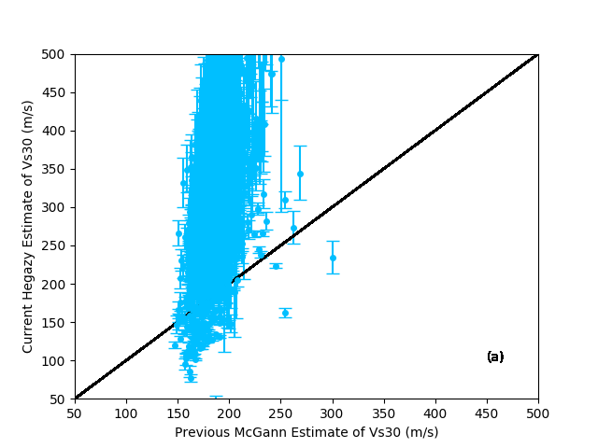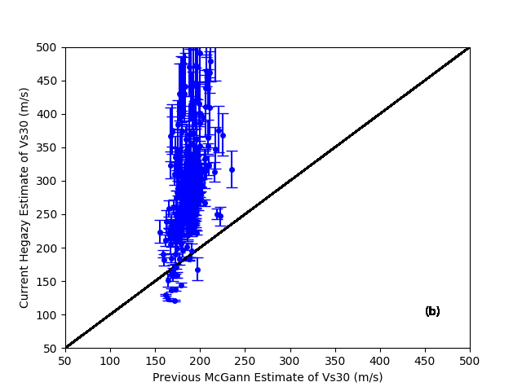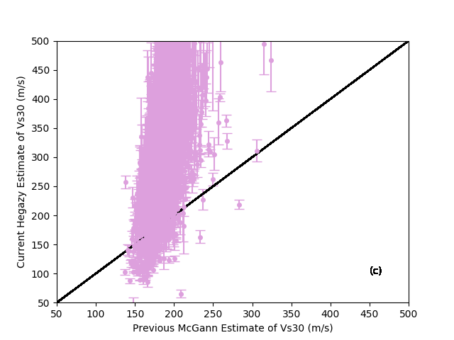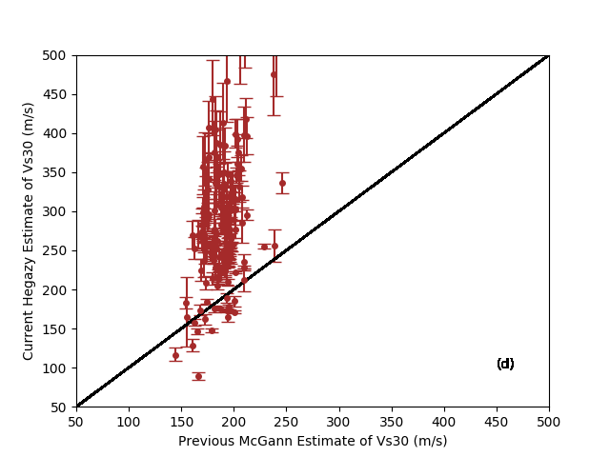

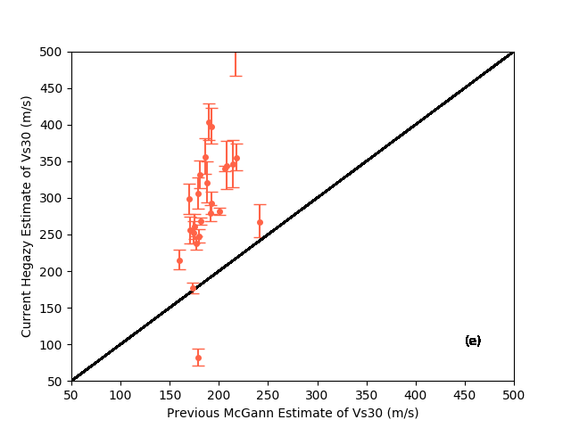

Figure C2. Hegazy correlation estimates divided into five surficial geology categories: (a) dune, (b) estuarine, (c) alluvium, (d) swamp, and (e) volcanic

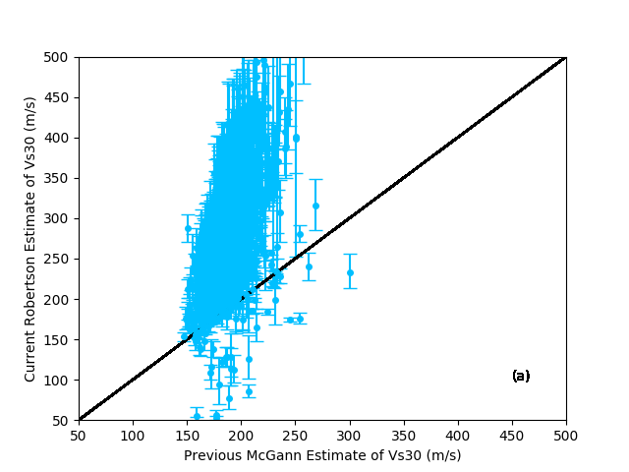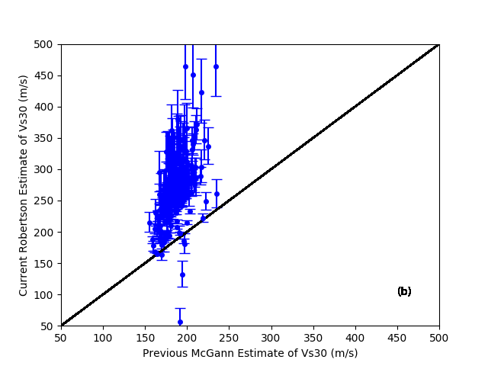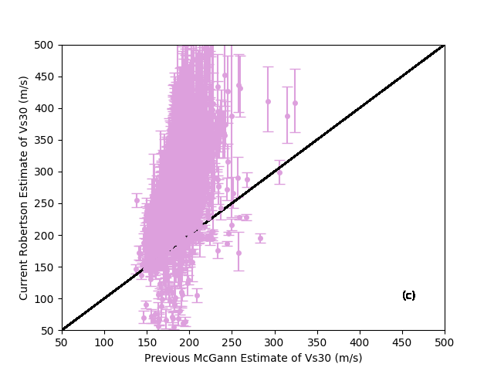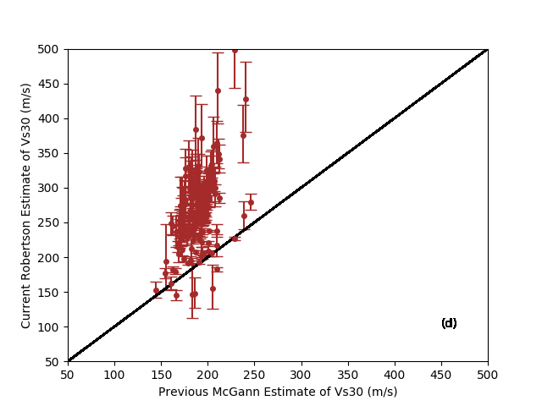

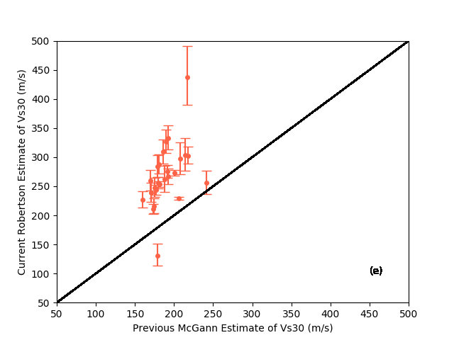

Figure C3. Robertson correlation estimates divided into five surficial geology categories: (a) dune, (b) estuarine, (c) alluvium, (d) swamp, and (e) volcanic

1. Termination depth for Christchurch CPT tests

Figures/Gravel:Failure%20point%20plots/plot_term.pdf

Figure E1. Termination depth for the greater Christchurch CPT tests in m